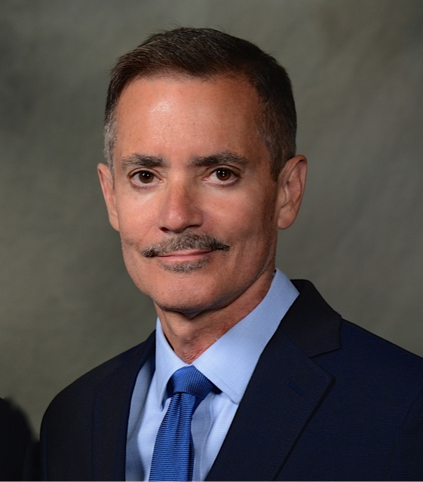
William Repicci is the President & CEO of the Lymphatic Education and Research Network (LE&RN). Since joining LE&RN in 2011, he has led the organization through a rebranding, leading to an expanded focus on education, research & advocacy for all lymphatic diseases. Signature programs include the establishment of the first-ever Centers of Excellence in the Treatment of Lymphatic Diseases, the awarding of research fellowships, the establishment of World Lymphedema Day on March 6th by the US Senate, the peer-review journal Lymphatic Research & Biology, the International Patient Registry & Biorepository, Lymphedema Therapist Scholarships, Investigator Travel Awards, Livestream Symposium Series, State & International Chapters, bi-weekly e-news outreach and ongoing efforts with NIH and government to increase lymphatic research funding. In 2018, he wrote a first-in-nation bill signed by the Governor of New York State, which obligates hospitals to dispense lymphedema information packets to all at-risk patients. He also spearheaded the successful effort to have the National Institutes of Health establish a National Commission on Lymphatic Diseases, is the Primary Investigator on a Chronic Disease Education & Awareness grant funded by the Centers for Disease Control & Prevention (CDC), succeeded at efforts to have “lymphatic diseases” and “lymphedema” added for the first time as eligible for research funding through the Department of Defense’s medical research program (PRMRP), and led the initiative that led to a lymphatic project at the Advanced Research Program Agency in Health (ARPA-H). He has over 30 years of experience leading nonprofit organizations and businesses, including directorship of humanitarian programs in Northern Kenya, managing director of the National Theatre of the Deaf, CEO of the Fairbanks Resource Agency serving persons with developmental disabilities in Alaska, executive director of the Pasos Peace Museum in New York City and CEO of a dramatic publishing company. In 2013, he was awarded the ANCOR Legacy Leadership Award for his career accomplishments in advocacy efforts. Under his own theatrical management company, he has produced or managed over 35 plays and musicals in NYC, London, and on tour. Among these is the Off-Broadway musical, “Swingtime Canteen,” which he co-authored. His jazz-era documentary “The Ladies of Grove Street” aired on PBS stations nationwide. He has graduate degrees in Global Affairs (New York University), Behavioral Psychology (University of Wisconsin-Madison), Administration (Seattle University), Psychology (Catholic University of America), and a BA in Philosophy (Le Moyne College).
__________________________________________________________
Short bio:
William Repicci is President & CEO of the New York City-based Lymphatic Education and Research Network (LE&RN), whose mission is to fight lymphatic diseases (LD) such as lymphedema, lipedema, and lymphatic anomalies through education, research, and advocacy. His career has focused on executive positions associated with social change, from running organizations for the developmentally disabled and the deaf to producing issue-oriented plays during his many years in the theatre and publishing worlds. He wrote the United States Senate bill establishing World Lymphedema Day on March 6th. He also initiated successful campaigns leading to the National Commission on Lymphatic Diseases at NIH, an Advanced Research Program Agency in Health (ARPA-H) Lymphatic Project, a three-year cancer-related lymphedema awareness campaign funded by the Centers for Disease Control and Prevention, and lymphedema and lymphatic disease inclusion as eligible for research funding through the Dept. of Defense’s Peer-Review Medical Research Program (PRMRP). He secured activist actor Kathy Bates as LE&RN's international spokesperson. He has focused his 12 years at LE&RN on deconstructing the obstacles to lymphatic disease awareness and building a campaign to make it a global priority.
________________________________________
Bio in less than 140 characters: William Repicci is President & CEO of the Lymphatic Education and Research Network (LE&RN).

